Executive Summary

Search bar functionality in the extension will allow all Haibrid users to quickly find and navigate to any saved
web source and Haibrid projects within a selected workspace, saved either by them or shared by their teammates.
By reducing additional steps needed to open the webpage, search for projects and then search for sources within
projects, it enhances workflow efficiency and saves time, resulting in increased user satisfaction and retention.

Target Release
Epic | HAIB-737
Figma | https://www.figma.com/design/n2FYTev0A6bT7CCK3626BR/Haibrid-DS-v1.2?node-id=3971-39042&t=iqWmZ8aryaK03fJf-4
Document Status | {READY}
Owner | Tatevik Azoyan

Objective

- Increased Productivity: Reducing cognitive load and improving users’ efficiency
- Increased usability of extension: Boosting extension’s value as one of Haibrid’s unique features and key user activation point.

Assumptions

- Users may want to search for their saved source at random moments of web surfing and would like to have such opportunity without opening Haibrid main webpage
- Users might want to open that web source with the least number of steps possible
- Users may not remember/know which project a specific source was saved to, which makes it very difficult to find a source in the main webpage

Success metrics
List project goals and the metrics you'll use to judge its success

Goal | Metric
Requirements

- Changed source saving flows, need to indicate projects where the source is already saved to (if already saved)
- Add search ability
- Add search filtering
- Add redirecting to web URLs after searching
User interaction and design

- Source saving flow changes

- When the user clicks on the Haibrid Extension, they should see the extension window in the new style/size (300 px wide)
- When the user clicks on the “Edit” button on the snackbar, the snackbar should expand into the Extension window (the same as when clicking on the Haibrid icon). In general, the same extension view should be opened either by clicking on the icon or righ click → Save to Haibrid → Edit. Need to make sure that when clicking on the extension icon, the source doesn’t save automatically.

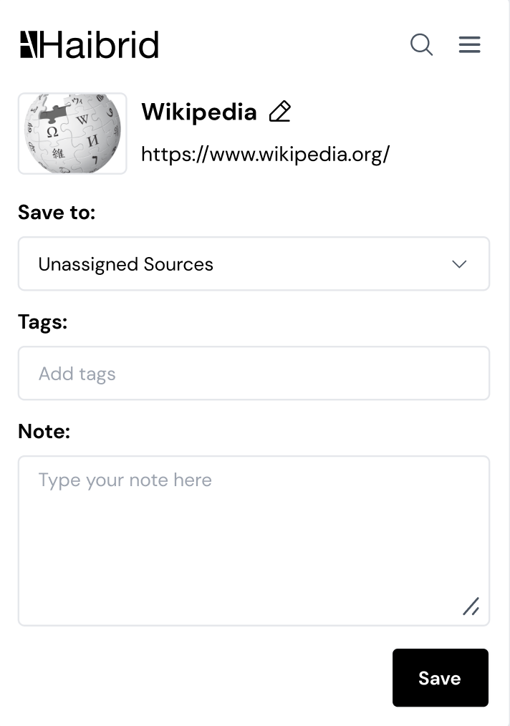

- When the user right-click saves to Haibrid, they should see the snackbar on the upper right corner of the screen (in the same width of the new extension window).

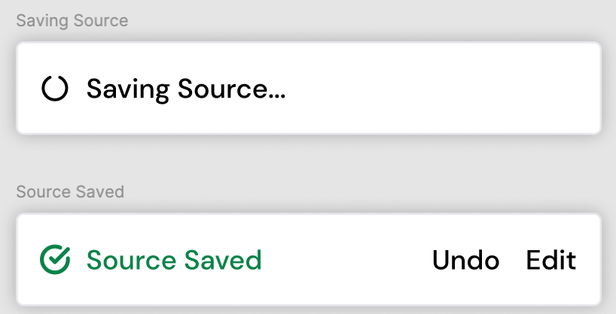

- When the user saves a previously saved source via right click action (without saving a highlight!), they should see the snackbar saying “Source Already Saved”, which should not have the “Undo” button, but only the “Edit” button on it.



- When clicking on the “Edit” button, the snackbar should expand into the extension window, and it should contain information about which project(s) the source has been saved to (if any). Each project name should be shown in a separate “highlighted box”; no limit for number of project names; name should be shown fully unless it’s too long, in this case “…” should be shown so that it fits into one line.
- When trying to save a previously saved source via the extension icon, the same Extension window should happen (with the info about the projects).
- When hovering on each project name, the project name should become a “link” to the main Haibrid web page, opening the specified webpage.

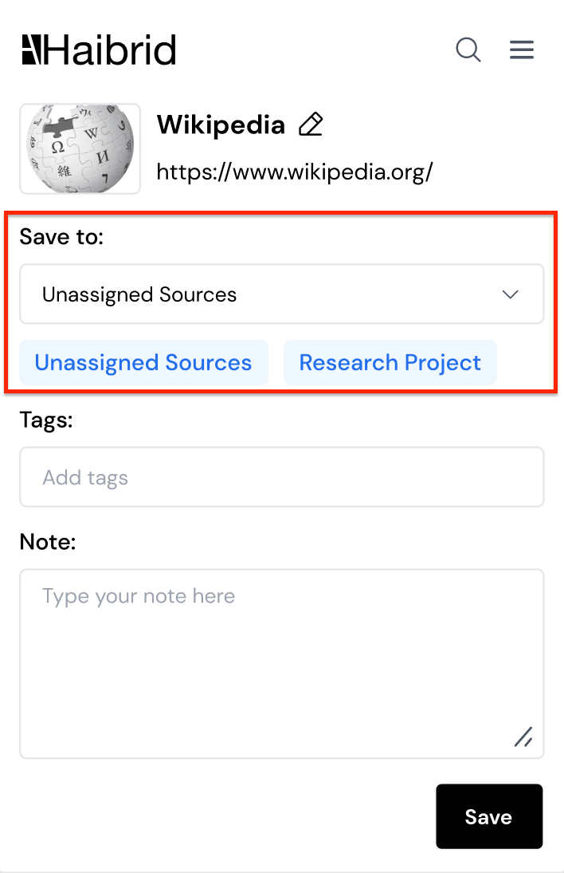
- When saving a highlight, there is no need to indicate projects where this source is saved to. Need to make UI adjustments to highlights section:

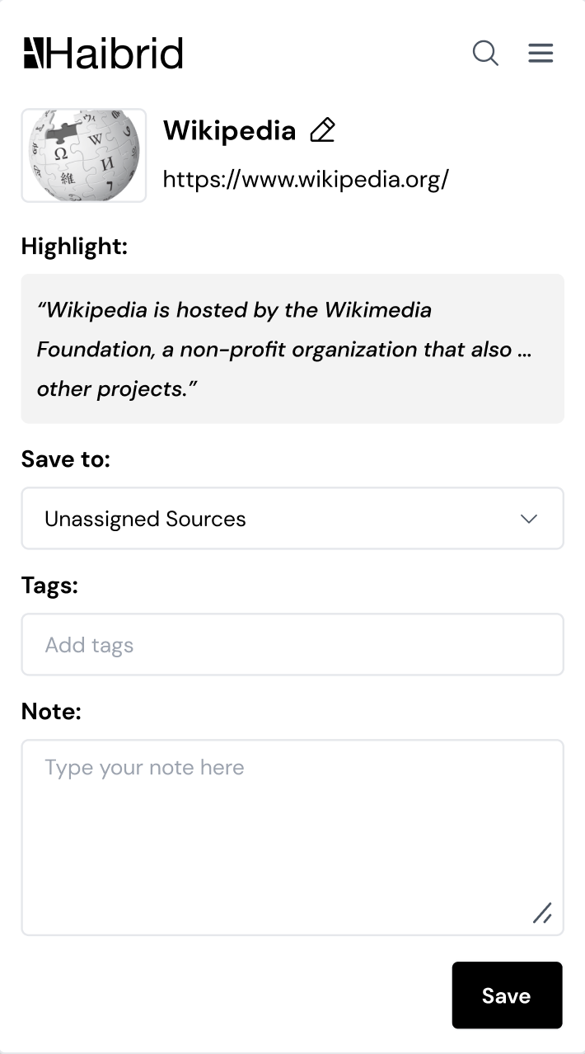

- Search Flow

There should be a search button, and users should see “Search Sources” tooltip when hovering on it:

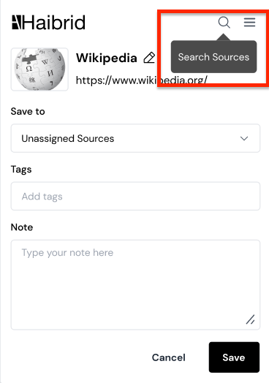
- When the user clicks on the search icon, the search input should expand and Recently Saved 5 Sources should be displayed (no scroll needed):

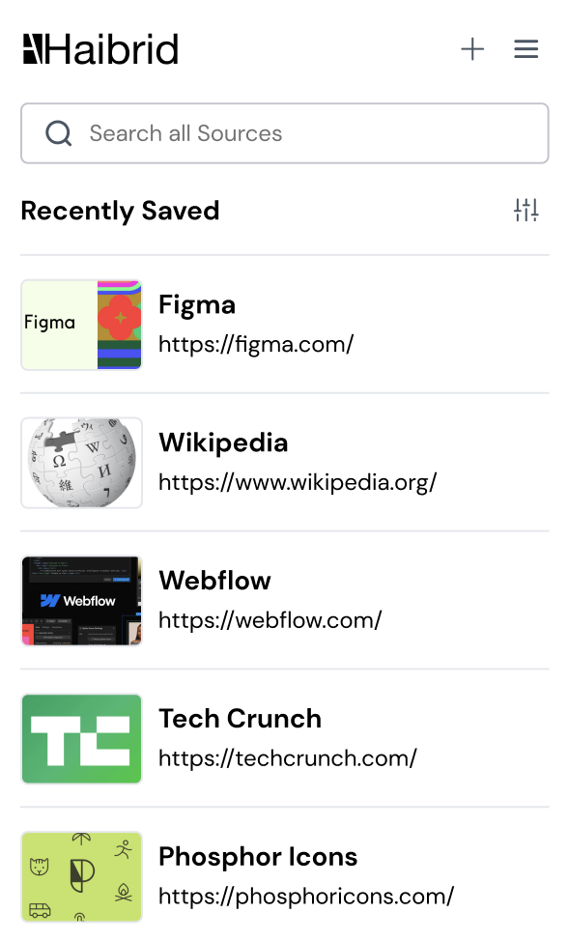

- If any of the sources don’t have a thumbnail, there should be a placeholder image instead:
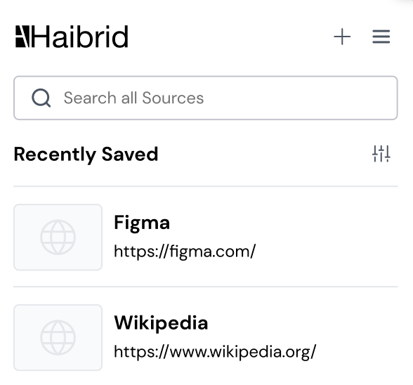

- When the user starts typing in the search input, the list of the sources should update accordingly, leaving only the sources that match the search result, and number of sources should also be dynamically updated:

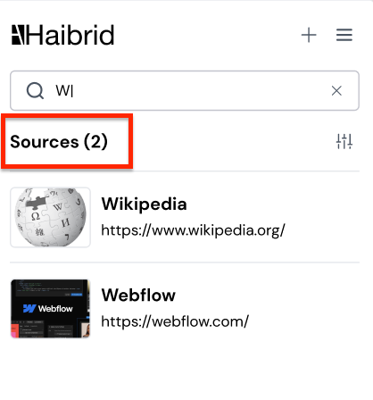

- If there are too many search results, the user should be able to see the sources that fit into 520px height (which should be 5 sources and a bit of the 6th one), and have access to the rest while scrolling.

- The user should see a “No Sources Found” message when there are no search/filter results:

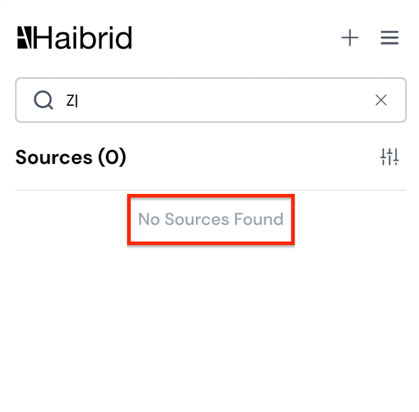

- Clicking on “X” should delete everything from the “Search” input, and the default “Recently Saved” view should appear:

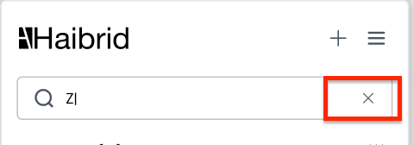
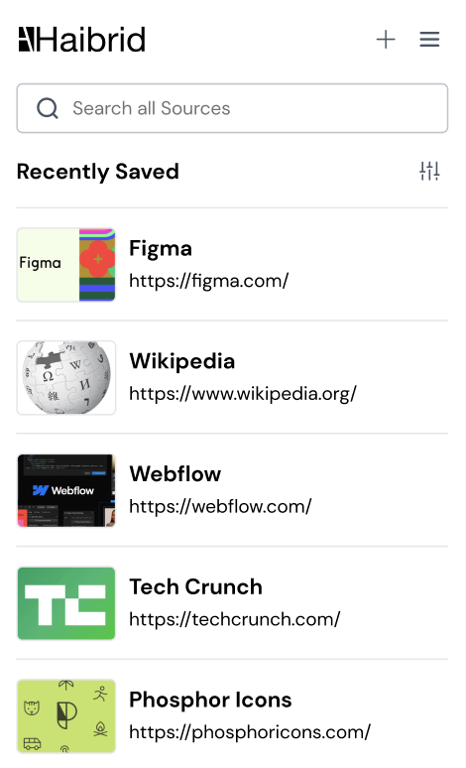

- When clicking anywhere on any of the sources displayed in the search view, the user should be redirected to that web source on a new tab.
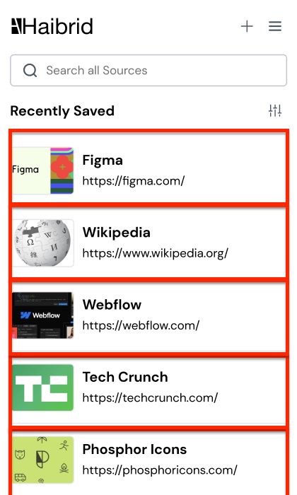

- When hovering on the “+” button, “Add Source” tooltip should appear. When Clicking on the “+” button, users should be redirected to the default extension page (the button should act as “Close the search”).

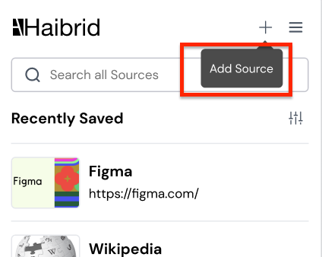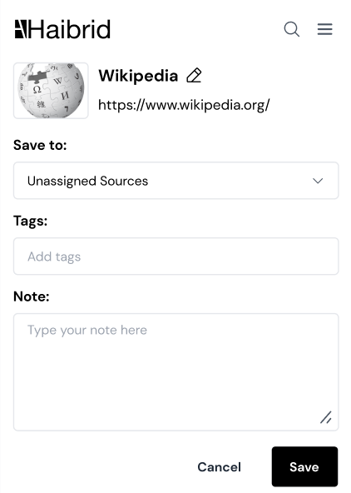

3) Search Filters

- The user should be able to apply a “Project” filter to the search results (and to the default view of recent sources - before even searching for something), by clicking on the filter icon and selecting a project.
- All projects within a workspace to which the user has owner/editor rights should appear in the dropdown/project search.

- There should be a search field when filtering projects, also 3,5 projects should be displayed with the ability to scroll. Projects should be shown ordered by the recency of interaction. Search dropdown can be increased in its width, but should never exceed the original fixed width of the extension (same way it works currently). However, if the project name is too long, it shouldn’t be shown in several lines, instead, a “…” should appear at the end of the name to fit within a single line.

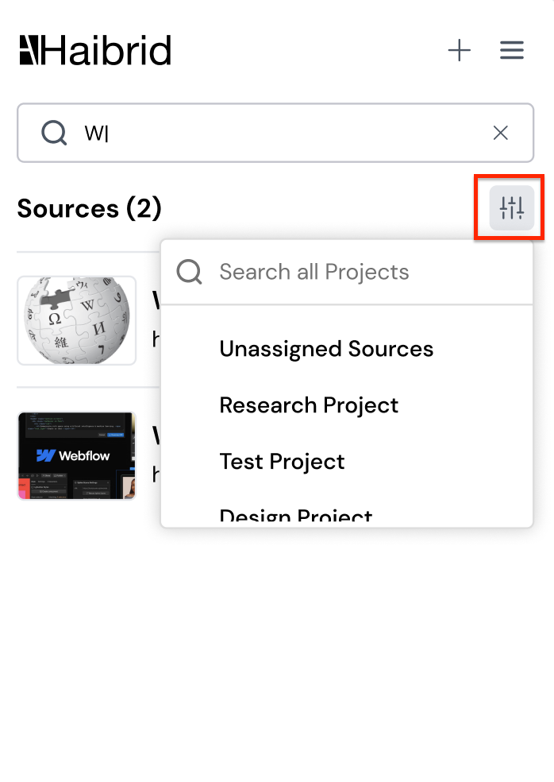
- After selecting a project the dropdown should be closed and the filter should be applied.
- A red dot should appear on the filter button, indicating that a filter has been applied.

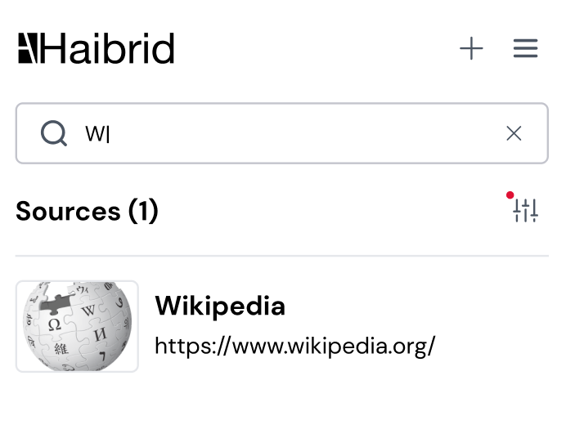
- When clicking on the filter button again, the user should see the selected filter (project name) on top of the list in the dropdown and with a checkmark beside the name, and be able to clear the filter by clicking anywhere on the selected project name one more time. The dropdown should close and the red dot should disappear, indicating that there are no filters applied:

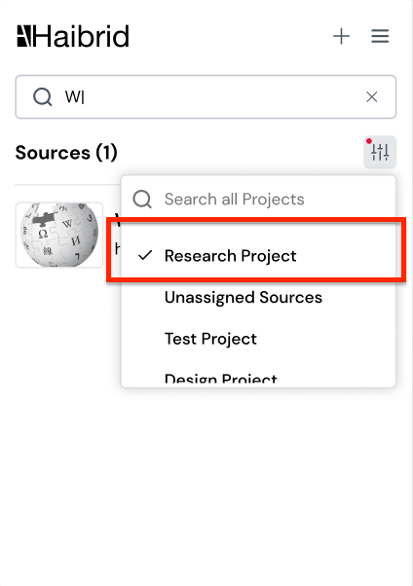

Open Questions

- Should we indicate “Saved to” projects when saving a highlight? (NG:No)

Out of Scope
- Showing who saved the source
- Showing the date added for each source
- Adding other filtering options to the search result (such as saved by the user vs. shared by others, etc.)
- Highlighting with color the part of the text in the URL/Source name that matches the search input

